

Europass  Curriculum Vitae |  | 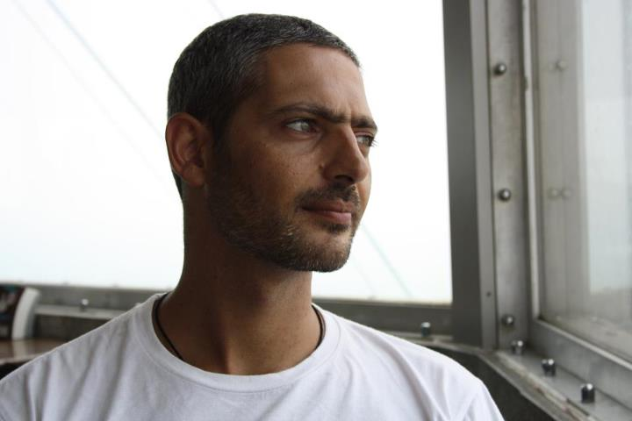
Personal information
First name(s) / Surname(s) |  | LIATAKIS, Vasileios
Address(es) |  | 1 Galilaiou Street, 4632, Kolossi, Limassol, Cyprus
Telephone(s) |  | +357 25106995 | Mobile: | +357 96728253
Fax(es)
E-mail |  | technofreakcy@gmail.com
Nationality |  | Hellenic
Date of birth |  | 26/11/1977
Gender |  | Male
Desired employment / Occupational field |  | Bank Teller, Secretary, IT Support “Anything Availible”
Work experience
Dates |  | From September 2009 to September 2011
Occupation or position held |  | Head Technician of Service Department
Main activities and responsibilities |  | Diagnosis, Repair of Desktop Computers, Notebooks and Netbooks  Customer support over the phone  Local and Wide Area Network Setups and maintenance  Installation of the following operating systems, drivers and relevant software to meet clients needs  Windows 98, Windows ME, Windows NT4, Windows 2000, Windows XP, Windows Vista, Windows 7, Windows 2003 Server, Windows 2008 Server.
Name and address of employer |  | Mr. Dimitris Tsakas (PC Doctor) Koroneou 16, 73100, Chania, Crete, Greece  +30 28210 79790, +30 6932211193
Type of business or sector |  | IT - Hardware / Customer Support
Education and training
Dates |  | February 2002 to February 2009
Title of qualification awarded |  | Degree in Applied Informatics & Multimedia
Principal subjects/occupational skills covered |  | Hardware  Digital Circuit Design  Introduction to Electronics  Computer Architecture  Digital Communications  Digital Signal Processing  Integrated Services Communications  Operating Systems  Distributed Systems  Embedded Systems  Network  Data Networks  Computer Networks  Wireless Networks  Mobile & Personal Telecommunications  Multimedia  Introduction to Multimedia Technology  Technologies for Audio Visual Content Creation  Programming/ Web Design  Object Orientated Programming  Introduction to Databases  Internet Programming  Distributed & Internet Multimedia Applications  Thesis  Dynamic system for automated enrolment, for the department of applied informatics and multimedia at TEI Crete.  Work Experience
Dates  Occupation or position held  Main activities and responsibilities  Name and address of employer  Name and type of organisation providing education and training |  | From June 2008 to December 2008  Technician  Network, Rack Server Setup and Installation  Printer, Desktop, Netbook and Notebook Setups and Repairs  Customer Support.  Polixronis Kyriklakis (T3)  16 Ipsilandon Street, 73100, Chania, Crete, Greece  Department of Applied Informatics & Multimedia  TEI of Crete  Heraklion Crete  71400  Greece
Level in national or international classification |  | Level 5

Personal skills and competences
Mother tongue(s) | English
Other language(s)
Self-assessment |  | Understanding |  |  |  | Speaking |  |  |  | Writing
European level (*) |  | Listening |  | Reading |  | Spoken interaction |  | Spoken production
Greek |  | C2 | Proficient User | C2 | Proficient User | C2 | Proficient User | C2 | Proficient User | C2 | Proficient User
Social skills and competences | - Team Spirit  - Self Confident  - Good ability to adapt to multicultural environments  - Outgoing, friendly character
Organisational skills and competences | - Responsible  - Mature  - Organisational Skills  - Efficient, and very hands on  - Articulate  The above skills were attained through my experience from running the PC Doctor service centre.
Driving licence | UK Categories B, BE, B1, fkp
Additional information | I enjoy travelling, swimming, diving and rock climbing, as well as watching the occasional game of boxing or rugby.

